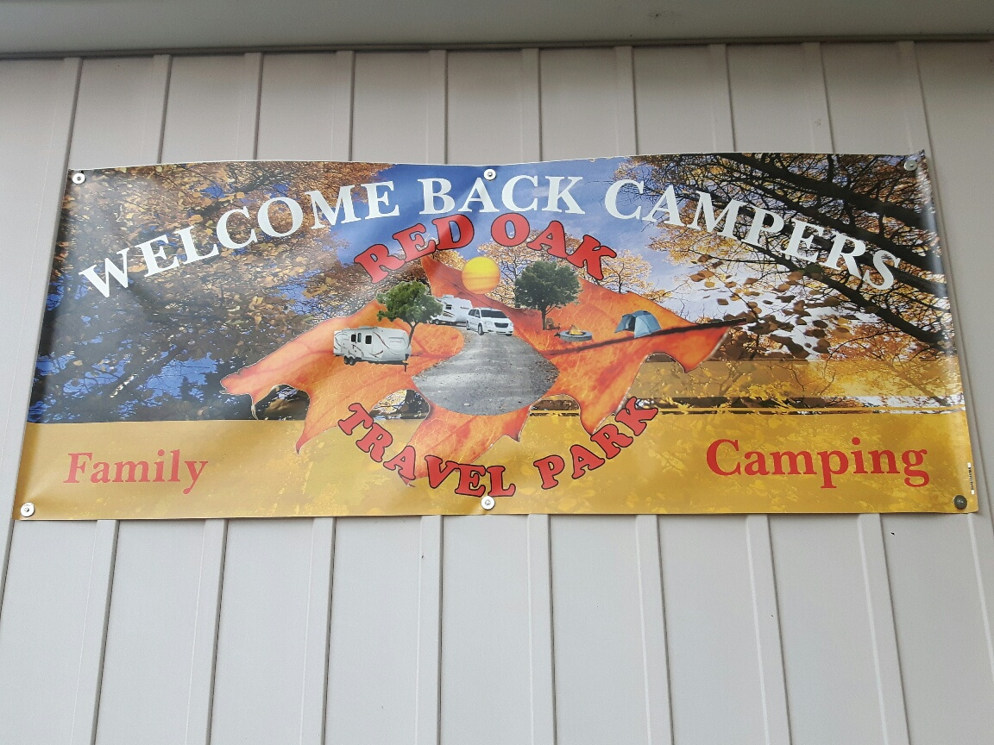 | May 2024
Site Draw Tickets for 2025 Available
Mon. | Tue. | Wed. | Thu. | Fri. | Sat. | Sun.
Welcome Campers!! The Park is Officially Open  Park is Officially OPEN!! | 50/50 Draw Weekly: Tickets Sold Every Saturday | 1 | 2 | 3 | 4 | 5
 |  | Mother’s Day Specialty Draw (tickets on sale) |  |  | Kid’s Club: Mother’s Day Craft 11am  Hot Dog BBQ Lunch 12-1pm
6 | 7 | 8 | 9 | 10 | 11 | 12
 |  |  |  |  | Pancake Breakfast  9:30 -11:00  *Mother’s Day Draw (evening) | Mother’s Day
13 | 14 | 15 | 16 | 17 | 18 | 19
 |  |  |  | Adult Darts 8pm | Kids Craft 11am  Horseshoes 1pm  Live Entertainment (Evening) | Kids Egg Hunt 2pm  Adult Bingo 7pm
20 | 21 | 22 | 23 | 24 | 25 | 26
Victoria Day |  |  |  |  | Social/Camper Mtg. 11am  * Spaghetti Dinner 5pm  (Complimentary) | *Coffee Social 10:30am  *Mystery Gift Exchange 11am
27 | 28 | 29 | 30 | 31 | **ALL EVENTS/ACTIVITIES ARE DEPENDANT UPON  VOLUNTEERS AND WEATHER  **Success and occurrence of activities relies on  camper participation…  YOU decide!
 | **Sign up for Pig Roast on the 29th…Watch for Volunteers coming around |  |  | Kids Bingo 7pm
SPRING CLEAN UP: Let’s work together like we do in the fall and get the park ready for a
Fantastic 2024 Season!!
Reminder: Please let the office know well in advance when you are in need of firewood.

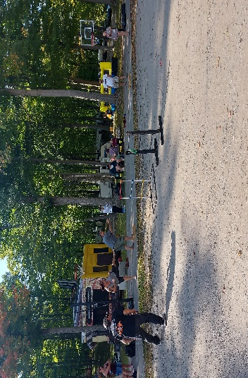 | June 2024
Site Draw Tickets for 2025 Available
Mon. | Tue. | Wed. | Thu. | Fri. | Sat. | Sun.
50/50 Draw Weekly: Tickets Sold Every Saturday | Isaac’s Baked Goods (Horse Drawn Carriage) Most Saturdays through the summer |  |  |  | 1 | 2
 |  |  |  | Father’s Day Specialty Draw (tickets on sale) | Crokinole @ The Rec Hall 2pm  Karaoke Kids 7-8pm Adult 8-10pm
3 | 4 | 5 | 6 | 7 | 8 | 9
 | **Sign up for Bacon Fest on the 22nd!! ^{Watch for Volunteers} |  |  | Adult Darts 8pm | Kids Craft: Father’s Day 11am  Euchre 7pm
10 | 11 | 12 | 13 | 14 | 15 | 16
Donations Needed for Penny Sale (info to follow) |  |  |  | Adult Bingo 8pm | Eggs N’ Stuff Breakfast  9:30 – 11:00am  Kids Bingo 3pm  *Father’s Day Draw (Evening) | Father’s Day
17 | 18 | 19 | 20 | 21 | 22 | 23
 |  |  |  |  | Social/Camper Mtg. 11am  Horseshoes 1pm  Bacon Fest  (Rec Hall 5pm Sign up Required) | *Coffee Social 10:30am  *Mystery Gift Exchange 11am
24 | 25 | 26 | 27 | 28 | 29 | 30
Site Decorating for upcoming Canada Day (Long Weekend!) |  |  |  | Canada Day Celebrations Begin  Family Movie Night (Dusk) | *Penny Sale  (9-11am)  Pig Roast 5pm (Sign up Required)  *Live Entertainment 7pm | *Bike/ Golf Cart Parade 12:30  *Cake/Ice Cream Social 1pm (Outside Rec Hall)  *Street Dance (Bear Shack) **Fireworks
Volunteer | A Little Bit of Your Time…  Allows for great activities being hosted around the park throughout the season. We all have something to offer! Check out the sign-up sheets at the office.  Your participation is vital! Events are scheduled/planned with past involvement as a guide. Come out and enjoy these events … invite your family/friends. There are GREAT people and events right here at RED OAK!!

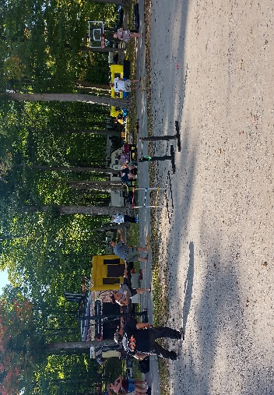 | July 2024
Site Draw Tickets for 2025 Available
Mon. | Tue. | Wed. | Thu. | Fri. | Sat. | Sun.
1 | 2 | 3 | 4 | 5 | 6 | 7
Canada Day | Isaac’s Baked Goods (Horse Drawn Carriage) Most Saturdays through the summer |  |  | Christmas in July Specialty Draw (Tickets on Sale)  Adult Darts 7pm | Karaoke  Kids 7-8pm Adults 8-10pm
8 | 9 | 10 | 11 | 12 | 13 | 14
50/50 Draw Weekly: Tickets Sold Every Saturday |  |  |  | Adult Bingo 8pm | Kid’s Craft:10am (Christmas)  Horseshoes 1pm  Family Bingo 2pm
15 | 16 | 17 | 18 | 19 | 20 | 21
 | Coming Soon..Christmas in July Weekend  Begin Your Site Decorating |  |  | Ice Cream Social 7pm  Christmas Specialty Draw (8pm) | Santa in the Park!! 2pm  *Pot Luck 5:00 pm  *Movie Night @dusk | Social/Camper Mtg. 11am
22 | 23 | 24 | 25 | 26 | 27 | 28
 |  |  |  | Kids Bingo 7pm | *Coffee Social 10:30am  *Mystery Gift Exchange 11am  Euchre 7pm
29 | 30 | 31

POOL TIME | The Heat is On!!  The pool has a limit of 10 persons in the enclosed area at a time. This is a bylaw issue, so being respectful of your time in the pool will ensure that everyone gets a chance to cool off. **Remember to use sunscreen when outdoors.
Reminder: Please let the office know well in advance when you are in need of firewood.

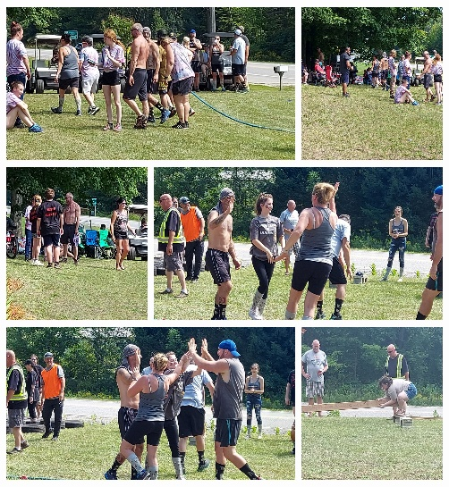 | August 2024
Site Draw Tickets for 2025 Available
Mon. | Tue. | Wed. | Thu. | Fri. | Sat. | Sun.
50/50 Draw Weekly: Tickets Sold Every Saturday | Isaac’s Baked Goods (Horse Drawn Carriage) Most Saturdays through the summer |  | 1 | 2 | 3 | 4
 |  |  | Celebrating Summer Specialty Draw (Tickets on Sale) |  | *Vendor’s Sale 10am-2pm  *BBQ Lunch 12pm  * 7pm LIVE ENTERTAINMENT | Pancake Breakfast 9:30-11:00  *Horseshoes 1pm
5 | 6 | 7 | 8 | 9 | 10 | 11
Civic Holiday |  |  |  | Adult Darts 8pm | Kid’s Carnival  Movie Night @ Dusk
12 | 13 | 14 | 15 | 16 | 17 | 18
2025 Committee Nominations Begins | Halloween Site Decorating for this coming weekend!! | Tickets for Pre-Sale 50ès Diner | Weekend of Talbot Trail Yard Sales | Euchre 7pm  Celebrating Summer Specialty Draw | Trick or Treating @6pm  Haunted House | *Coffee Social 10:30am  *Mystery Gift Exchange 11am
19 | 20 | 21 | 22 | 23 | 24 | 25
2025 Committee Nominations Closes |  |  | Weekend of Watermelon Fest in Stratfordville | Adult Bingo 8pm | Fish Fry  6pm  Rec Hall  (Sign up Required) | Social/Camper Mtg. 11am  Meet the Nominees  Voting Open for 2025 Committee Members
26 | 27 | 28 | 29 | 30 | 31
GET YOUR TEAM TOGETHER FOR THE LABOUR DAY GAMES!! |  |  |  | Voting CLOSES Tomorrow… August 31 for 2025 Committee Members | *Pancake Breakfast  9:30 – 11:00  Live Evening Entertainment

Notes | Labour Day Games  Gather some friends, bring your family…EVERYONE is sure to have a fantastic day. Sign up, and enter your team to participate in a variety of games that are sure to please participants and spectators!! BBQ Lunch offered!

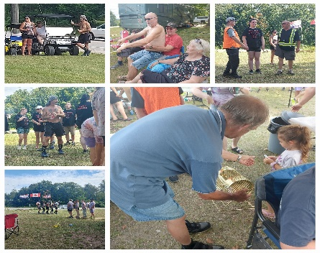 | September 2024
Mon. | Tue. | Wed. | Thu. | Fri. | Sat. | Sun.
 |  |  |  |  |  | 1
Site Draw Tickets for 2025 Available till Sept. 15 @ 6pm |  |  | Last long weekend of the Summer….Make it a GREAT one!! | Register your team today for the annual games!! |  | *Labour Day Games 10am *50’s Diner Dinner  *Live Evening Entertainment
2 | 3 | 4 | 5 | 6 | 7 | 8
Labour Day | Kids return to school |  |  | Adult Darts 7pm | Family Bingo 2pm  Adult Bingo  7pm
9 | 10 | 11 | 12 | 13 | 14 | 15
 |  |  |  |  | Pot Luck Supper 5pm  **Site Draw Winner Announced 7pm | Social/Camper Mtg. 11am
16 | 17 | 18 | 19 | 20 | 21 | 22
 |  |  |  |  | Crokinole @ The Rec Hall 2pm | *Coffee Social 10:30am  *Mystery Gift Exchange 11am
23 | 24 | 25 | 26 | 27 | 28 | 29
 |  |  |  | Silent Auction At Tomorrows Thanksgiving Dinner!! | Thanksgiving Dinner 5pm  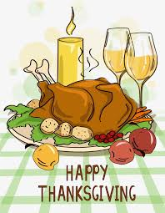
30
Park Closing | TIPS:  Please be sure that your trailer has been properly winterized.  Make sure all items stored outside are properly secured.  Dispose of all garbage, leaving no debris to be covered with leaves and fallen snow.  Make sure all bills are paid in full (makes for a happy Park Owner!)
Reminder: Please let the office know well in advance when you are in need of firewood.

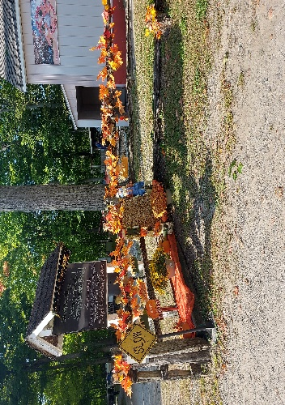 | October 2024
Mon. | Tue. | Wed. | Thu. | Fri. | Sat. | Sun.
2024… | 1 | 2 | 3 | 4 | 5 | 6
You’ve been an amazing season!! See you in 2025 |  |  |  | Welcome Sauders Family: Rec Hall Booked | Rec Hall Booked | Rec Hall Booked
7 | 8 | 9 | 10 | 11 | 12 | 13
 |  |  |  | 8pm Friends Gathering: Community Fire Outside Rec Hall | *Coffee Social 10:30am  ***Final Meeting 11am
14 | 15 | 16 | 17 | 18 | 19 | 20
Thanksgiving  Day | Park Closed for the Season
21 | 22 | 23 | 24 | 25 | 26 | 27
28 | 29 | 30 | 31 |  | Leaf Rake  Nov. 9 & 10  Hot lunch  provided 1pm
 |  |  | Halloween

Thanks | End of Season Is Here  This park is OUR park….we LIVE here, we PLAY here, we LOVE here. Thank you to ALL the volunteers and campers that helped make this year an incredible success!!  **Please remember to clean up around your site, and properly store any belonging/outdoor furnishings.

